Create a form **Varsity** as depicted below, further create a **ASP or MPF** file that will receive the **username** and **password** from the form and connect to the database to check if the credentials are correct. Username is a student number and password is a surname from the database table login.

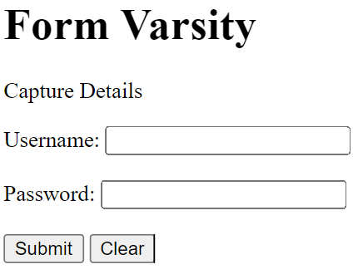

* **See Example below:**

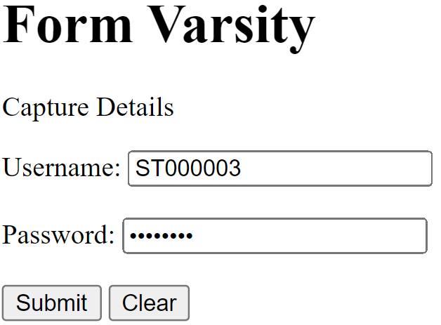

* If the **username** is not found in the database, the program must display a message ‘Login Failed, Username: Username Doesn’t exist’ and reload form varsity.html.
* See below.

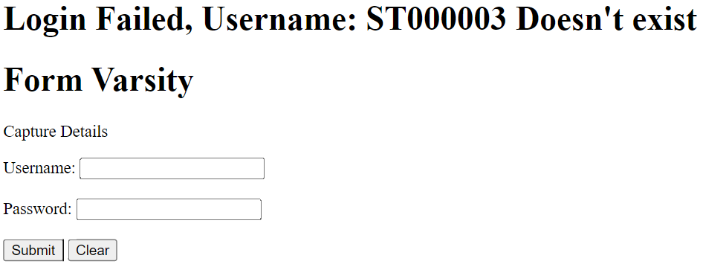

* If the **password** incorrect the program must display a message ‘Login Failed, incorrect password’ and reload form varsity.html.
* See below.

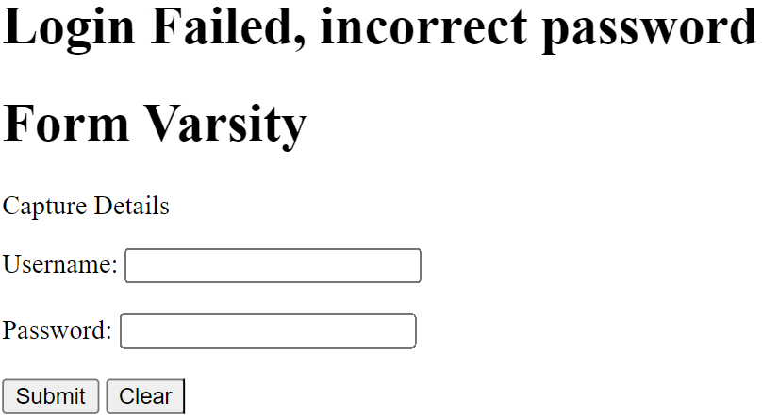

* When the **username** and **password** match the database credential the program must load form Marks.html as depicted below. With the message ‘Welcome #names_of_the_user’.

